♦ 1.TXT

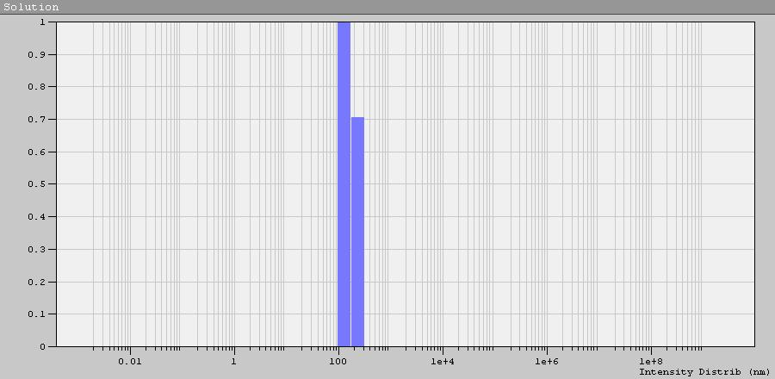

Peak Num | Area | Mean | Position | STD
1 | 1.000 | 178.0 | 132.4 | 62.73
χ ²: 0.004

♦ 2.TXT

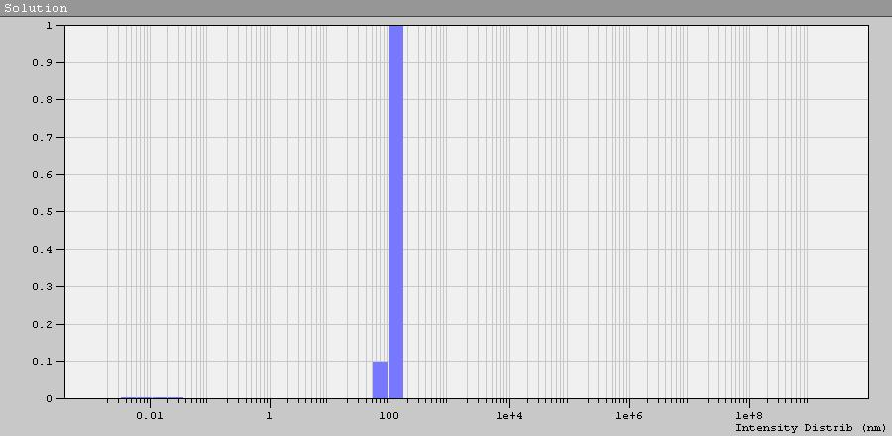

Peak Num | Area | Mean | Position | STD
1 | 1.000 | 127.1 | 132.4 | 27.65
χ ²: 0.004

♦ 3.TXT

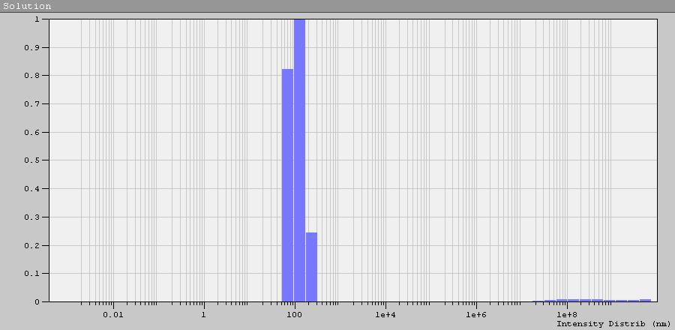

Peak Num | Area | Mean | Position | STD
1 | 1.000 | 118.6 | 132.4 | 59.20
χ ²: 0.005

♦ 4.TXT

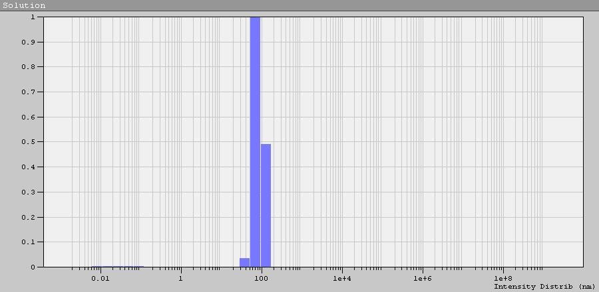

Peak Num | Area | Mean | Position | STD
1 | 1.000 | 90.97 | 72.32 | 33.23
χ ²: 0.004

♦ 5.TXT

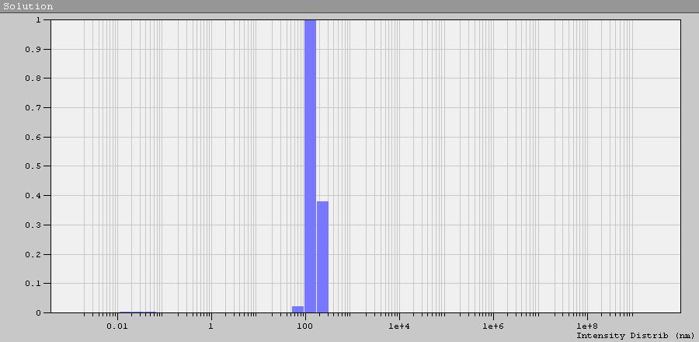

Peak Num | Area | Mean | Position | STD
1 | 1.000 | 161.6 | 132.6 | 57.65
χ ²: 0.003

